Kindergarten News

N

November 17, 2013

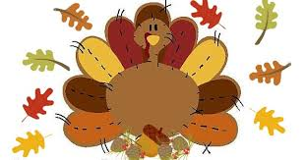

During the month of November we will be actively talking about the meaning of giving, how we as Kindergarteners can extend our hearts and give to others.

The week of November 18th, we are asking that each child bring in a gently used toy from their collection to donate to a worthy cause. Please do not go out and buy ANYTHING. The intent is for your child to give something that belongs to them.

Friendly Reminders:

1. Please send in a daily snack for your child. Teachers DO NOT supply snacks!
2. Please label your child’s jackets.

Peek at our Week

Language Arts:

* HFW: he. for, am, a, the, little, to, is, have, we, my, like (Be sure to practice these at home).
* Part of Speech – nouns, adjectives, Proper nouns, nouns for more than one
* Story Elements – Sequencing
* Initial and final Ii sound
* Comprehension skill: Classify and Categorize
* Beginning Sounds / Phonemic Awareness

Concept of a syllable

Writing with details

We have been invited to attend a play at WHS on Tuesday, Nov. 26th.We will be arriving back at FTE at 11:00. **Please send a sack lunch with your child. We will be eating in our class.**

**Hot lunches will NOT be served.**

***Upcoming Events***

*November 21st*, Boosterthon Fun Run

8:30 – K & 1st

November 26th, Field Trip to Westlake High School 9:30-11:00- SACK LUNCH

November 27th-29th, Thanksgiving Break

Peek at our Week:

Math:

* Number Boards
* Bar Graphs
* Sorting by attributes
* Rote counting 1-30
* Estimating
* Calendar activities
* Attributes of shapes
* Symmetry
* Coin Introduction
* Tricky Teens
* Positional words