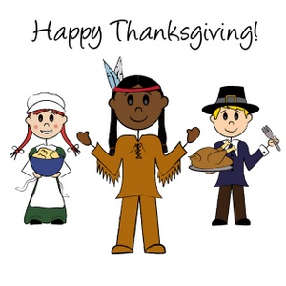

Kinder News

November 9, 2012

The Westlake Fire Department

visit was a huge success!

Monday from 9:30 – 10:00 a.m. is the **Veteran’s Day Assembly**.

Everyone is invited, especially Veterans, as we honor these heroes!

Peek at our Week:

Language Arts:

* HFW: I, am, a, the, little, to, is, have, we, my, like, for, and, he, (Be sure to practice these at home).
* Parts of Speech – nouns, adjectives, Proper nouns, nouns for more than one
* Story Elements – Realism Vs Fantasy
* Review initial and final (k) sound
* Isolate medial (i) as in pig
* Introduction to Spalding Phonemic Instruction
* Comprehension skill: compare and contrast
* Beginning Sounds / Phonemic Awareness
* Writing with details
* Adjectives for opposites

Concept of a syllable

Social Studies:

* Kelso’s Choices- Conflict Resolution
* Thanksgiving / Native Americans

|  |  |
| --- | --- |
| **Please send any clear plastic lids (Pringle cans, butter lids) for an upcoming art project we will be doing with our students by Thursday, November 15th.** | |
|  |  |

Peek at our Week:

Math:

* Number Boards
* Bar Graphs
* Sorting by attributes
* Rote counting 1-30
* Estimating
* Calendar activities
* Attributes of shapes
* Symmetry
* Coin Introduction
* Tricky Teens
* Patterning
* Positional words

Science:

* Growing Me
* Classifying

***Upcoming Events***

*Boosterthon- November 14th*

*Volunteers Needed*

*Contact nikkiperry@sbcglobal.net*

Thanksgiving Friendship Festival- November 16th starting at 11:15a.m. Students will rotate to 5 different stations extending into the afternoon. Contact teachers or room parent for

volunteer opportunities.

**Homework**

**Please log onto Reading Street:**

[**http://ftekinder.weebly.com/students.html**](http://ftekinder.weebly.com/students.html)

**for daily reading practice!!!**