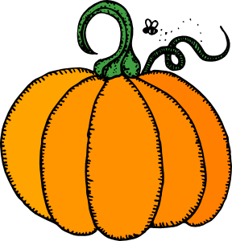

Kinder News

October 24th, 2013

Reminders

Please mark your child’s jackets, sweaters and accessories with his/her name. Our lost and found is overflowing! ☺

Peek at our Week:

Language Arts:

* Students will be responsible for knowing these HFW on their report card: I, am, a, the, little, to, is, have. (Be sure to practice these at home).
* Part of Speech – nouns, adjectives, Proper nouns, nouns for more than one
* Story Elements - Character, Setting, Plot, and Sequencing
* Initial and medial Aa, initial and final Ss.
* Review Spaulding Phonemic Instruction
* Comprehension skill: compare and contrast
* Beginning Sounds / Phonemic Awareness

Concept of a syllable

Social Studies:

* Kelso’s Choices- Conflict Resolution

Thank You’s!

1. Thank you to all those who participated in Pumpkins with Dad. It was a huge success!
2. Thank you to all parents for helping to make conferences run smoothly! We appreciate you making time in your busy schedules to work with us towards a successful Kinder year for your child.
3. Thank you to the people who made lunches for our staff during the three conference days! What a treat!

Peek at our Week:

Math:

* Recognizing numbers and writing numbers 0-20
* Sorting by attributes
* Rote counting 1-50
* Estimating
* Calendar activities
* Attributes of shapes
* Symmetry
* Coin Introduction
* Tricky Teens
* Patterning
* Positional words

Science:

* Living & Nonliving
* Classifying

***Upcoming Events***

*Science Fest October 31st*

*Late Start Day November 1st*

“You can find magic wherever you look. Sit back and relax, all you need is a book.”

- Dr. Seuss